
Washington Assessment
of Student Learning (WASL)

A Component of the Washington State Assessment Program

2003 Grade 5 Science Pilot Release

SYSTEMS
Properties
Structure
Changes
INQUIRY
Investigating Systems
Nature of Science
Design
Design Process
Science, Technology, & Society
Physical, Earth, Space, Life

Published by the Science Assessment Team of the Washington Office of the Superintendent of Public Instruction on October 14, 2003

Copyright © 2003 by Washington Office of the Superintendent of Public Instruction (OSPI)

All rights reserved. Educational institutions within the State of Washington have permission to reproduce this document. All other individuals wishing to reproduce this document must contact OSPI.
Table of Contents

Introduction to the Science Released Scenarios and Items 2

Fifth Grade Science Assessment Development Process 3

Science Assessment Leadership Team (SALT) 4

Characteristics of the Science WASL 5

Ideas for Using this Released Items Booklet 6
and Other Instructionally Supportive Science Assessment Materials
as Professional Development Opportunities

Loop-the-Loop: A physical science inquiry scenario with 6 items
Scenario Summary 7
Scenario 8
Items 1 – 4: Multiple choice items with characteristics 10
Item 5: Short Answer item with characteristics 12
Scoring rubric and annotated student responses
Item 6: Extended response item with characteristics 18
Scoring rubric and value point data
Annotated student responses

Item 7: Magnetic Force, a multiple choice stand alone item 32
Changes in systems, Nature of Force

Item 8: Lightning and Thunder, a multiple choice stand alone item 33
Properties of Systems, Wave Behavior

Item 9: Gaining Energy, a multiple choice stand alone item
Structure of Systems, Energy Transfers & Transformations 33

Item 10: Pencil System, a short answer stand alone item 34
Structure of Systems, Energy Transfers and Transformations
Introduction to the Science Released Scenarios and Items

We are delighted to offer these released scenarios and items from the statewide fifth grade science pilot (Washington Assessment of Student Learning given in the spring of 2003. This release booklet contains one scenario with associated items and four stand-alone items, about 25% of an operational exam. This release booklet is designed to assist teachers and administrators in understanding how the science WASL is written and how it measures students’ achievement of the science Essential Academic Learning Requirements (EALRs).

The science WASL is composed of scenarios modeling the three themes of the science EALRs: systems (including properties, structure and changes), inquiry, and design as shown on our science symbol on the front cover of this booklet. Students’ scores will be reported in five strands: properties of systems, structure of systems, changes in systems, inquiry in science, and designing solutions. The first fifth grade student, school, district, and state science WASL scores will be reported in August, 2004. No student scores are generated for any pilot exam; therefore, the release items in this booklet do not have student scores.

Systems scenarios describe a familiar system including some inputs, outputs, and transfers of matter, energy, and/or information. Students are asked to demonstrate their understanding of the system and what might happen as part of the system changes. About forty percent of the exam involves measuring systems learning targets. The stand alone item in this release booklet titled “Pencil System” is a good example of a simple system.

Inquiry scenarios describe a scientific investigation. Students are asked about the attributes of the investigation, asked to write conclusions, to make predictions, and how to deal with nature of science issues such as inconsistencies. Often students are asked to plan a new investigation similar to the scenario’s investigation. About forty percent of the exam involves measuring inquiry learning targets. The scenario in this release booklet, “Loop-the-Loop,” is a description of an investigation.

Design scenarios describe how a solution to a human problem or challenge was designed. Students are asked about the system being ‘fixed’ or manipulated and the use of scientific concepts and/or data in the solution. Often students are asked to describe how a solution could be designed for a new problem or challenge similar to the one described in the scenario. About twenty percent of the exam involves measuring design learning targets.

In addition to this booklet, there are many other instructionally supportive materials available for the science WASL including these released scenarios made into mini-science WASLs. To access these resources, please go to the OSPI website (www.k12.wa.us) and click to the science assessment webpage.

If you would like to become part of the Science Assessment Leadership Team (SALT) or have any questions or ideas, please contact Roy Q. Beven at rbeven@ospi.wednet.edu or phone (360) 725-6368.

Sincerely,
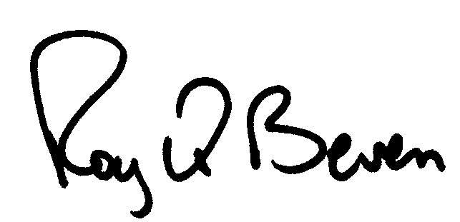
Roy Q. Beven
OSPI Science Assessment
Fifth Grade Science Assessment Development Process

The elementary science educators of the Science Assessment Leadership Team (SALT) have developed almost the entire fifth grade science WASL. With Washington teachers in the lead, concern for fairness and grade-appropriateness has always come first. The team has established clear guidelines for scenarios and items. To review theses guidelines, get a copy of the General Characteristics of the Science WASL or the Science Test and Item Specifications for Fifth Grade. These are available through the science assessment webpage on the OSPI website (www.k12.wa.us).

Scenarios are intentionally planned before writing starts. From the time it is planned, the process of getting a scenario onto an operational science WASL takes about two years. During that time, over one hundred science educators review the scenario and its items, and the scenario is piloted with about 1,500 students. Only those scenarios and items that survive this process will be on the 5th grade operational exams starting in 2004. The graphic below summarizes the WASL scenario development process.

Planning Scenarios with Items
SALT Members
Science Assessment Leadership Team (SALT)
WA Science Educators
Established Feb 2002

Writing Scenario

with Items
SALT Members
Content Review
WA Science Educators & Riverside Publishing

Fairness Review
WA Educators, OSPI,
& Riverside Publishing

Pilot Testing
WA Students,
Administrator,
& Teachers

Range Finding
SALT Members, Riverside,
& Pearson

Scoring
Pearson
Educational Measurement

Data Review
SALT Members, OSPI,
& Riverside Publishing

Operational Scenario & Item Bank

Operational

Science

WASL

Range Finding
SALT Members, Riverside,
& Pearson

Scores Released
to Districts in August
Students in September

Items Released
with Annotations
(and Data beginning in 2004)

Scoring
Pearson with
WA Science Educators & others

Professional Development Geared Toward Classroom Based Assessment

District & Regional Assessment Efforts

Science Assessment Leadership Team

In 2002, the OSPI science team started a program to increase the state’s capacity to do high quality science assessment by forming the Science Assessment Leadership Team (SALT). This team is currently composed of about 88 science teachers and educators from elementary, middle, and high school, higher education, and informal education. The SALT members from each ESD are ready to assist the schools in their region. The following SALT members work toward these goals:
- Increase expertise in science concepts, processes, and assessment
- Disseminate assessment information through professional development to each ESD region
- Develop and refine the science WASL
- Develop, test, revise, and disseminate classroom-based assessment

Anderson, Stewart: Grant ES, Eastmont SD
Arlington, Jeff: Connell HS, North Franklin SD
Baar, Barbara: retired MS, North Thurston SD
Bell, Kelly: Manson HS, Manson SD
Blagsvedt, Don: Science Facilitator, Tacoma SD
Boatman, Georgia: Southgate ES, Kennewick SD
Bonney, Joyce: Lynnwood ES, Edmonds SD
Boyd, Andy: Evergreen HS, Evergreen SD
Brown, Taunya: Orchard MS, Wenatchee SD
Brumley, Jewel: West Valley JHS, West Valley SD
Burbacher, Tom: Environmental Health, UW
Cunningham, Martha: Acme ES, Mt Baker SD
Darley, Cathy: Omak MS, Omak SD
Delgadillo, Georgiann: Mountain View MS, E. Valley SD
DiLoreto, Angie: Tyee MS, Bellevue SD
Dodd, Brett: Rogers HS, Spokane SD
Duncan, Keith: Kamiakin HS, Kennewick SD
Ferguson, Eric: MS Science Specialist, Bellevue SD
Fisk, Kathy: Desert Hills MS, Kennewick SD
Fredeen, Hanna: Frontier MS, Moses Lake SD
Frevert, Katie: Environmental Health, UW
Gady, Sandy: Beaver Lake MS, Issaquah SD
Garlich, Emily: Shelton HS, Shelton SD
Gromus, Al: Mt. High School, Mt. Vernon SD
Gursky, Larry: Science Specialist, Bethel SD
Hopoi, Beverly: Holmes ES, Spokane SD
Horton, Anna: Middle Scholl, Renton SD
Jacobsen, Debbie: Meadowdale MS, Edmonds SD
Johnson, Nikki: Squalicum HS, Bellignham SD
Johnson, Joanne: Sci. Curriculum, ESD 189
Johnson, Larry: Gig Harbor HS, Peninsula SD
Jones, Elaine: East Valley ES, East Valley SD
Koester, Chris: Moses Lake HS, Moses Lake SD
Kveven, Ardi: Snohomish HS, Snohomish SD
Larowe, LeeAnn: Elem. Science Specialist, ESD 112
Leifer, Rosemary: Sierra Heights ES, Renton SD
Levias, Sheldon: MS Science Specialist, Seattle SD
Lindley, Scott: Mt. Lake Terrace HS, Edmonds SD
Linneman, Scott: Geology & Sci Ed, WWU
Lisoskie, Patricia: Black Hills HS, Tumwater SD
Lund, Tony: Wilson HS, Tacoma SD
Lye, Trudy: Columbia Burbank ES, Burbank SD
Madsen, Karen: Everett School Board
Matsumoto, Karen: Puget Sound Env. Center
McClellan, Mary: Sec. Science Specialist, Seattle SD
McDaniel, Kathy: Allen Creek ES, Marysville SD
McKean, Heather: Biology & Sci.Ed, EWU
McLeod, Jack: Cascade HS, Everett SD
Mincks, Rena: Jefferson ES, Pullman SD
Moore, Mary: Jason Lee ES, Richland SD
Moore, Tom: Elem. Principal, West Valley SD
Ohana, Chris: Elementary Sci Ed, WWU
Otto, Patricia: Environmental Ed, Seattle SD
Owens, Katie: Seth Woodard ES, West Valley SD
Parrow, Karen: Discovery MS, Vancouver SD
Parton, Cinda: Ferris HS, Spokane SD
Radford, Susan: North MS, Everett SD
Raudebaugh, Bob: Tech Ed. WWU
Ratz, Natalie: Heritage HS, Evergreen SD
Reid, Diane: Frontier MS, Moses Lake SD
Robbins, Kirk: Renton Park ES, Renton SD
Roland, Linda: Hearthwood ES, Evergreen SD
Schaaf, Sherrie: Science Coordinator, Quillayute SD
Schneider, Mark: Ferndale HS, Ferndale SD
Sheridan, Chris: Wilder ES, Lake Washington SD
Sherwin, Peter: Farwell ES, Mead SD
Smith, Ethan: Tahoma HS, Tahoma SD
Sotak, Bob: Science Curriculum Director, Seattle SD
Stark, Chris: Eastmont JHS, Eastmont SD
Stickel, Danielle: Selah JHS, Selah SD
Stranahan, Larry: Mt Spokane HS, Mead SD
Sullivan, James: Brier Terrace MS, Edmonds SD
Taylor, Minka: Fidalgo ES, Anacortes SD
Teppner, Brian: Sierra Heights ES, Renton SD
Thompson, Joseph: Science Specialist, Seattle SD
Tienhaara, Jonathan: Naselle MS, Naselle SD
Turrell, Awnie: Science Specialist, Seattle SD
Tyler, Laura: Washington MESA
Warren, Shannon: Middle School, Mt Vernon SD
Webster, Kathy: Beverly Park ES, Highline SD
Westfahl, Diane: Heatherwood MS, Everett SD
Windschitl, Mark: Elementary Sci Ed, UW
Wood, Mike: Middle School, Orting SD
Wright, Sally: Elma HS, Elma SD
Yergen, Midge: West Valley MS, West Valley SD

Characteristics of the Science WASL

The science WASL is a scenario-based exam that measures student achievement of the science EALRs. The fifth grade exam is composed of 38 items for 56 points to be given in three 60-minute sessions. The exam is in two booklets, a Directions and Scenario Booklet and a Student Response Booklet. With two booklets, students need not flip pages to refer to the scenario about which they are answering questions. The majority (55%) of the 5th grade science WASL is intended to measure students’ application of science concepts and understanding of science processes. Some other characteristics of the science WASL are listed below.

- At 5th Grade: 24 multiple-choice, 12 short answer, and 2 extended responses items
(At 8th and 10th Grades: 30 multiple-choice, 12 short answer, and 3 extended responses items)
- Five to six scenarios and several stand alone items. For example, an exam might include three inquiry scenarios, two systems scenarios, and one design scenario.
- 40% EALR 1: Systems in the physical, earth, space, and life sciences
The student understands and uses scientific concepts and principles to understand systems.
1.1 Properties of Systems: Use properties to identify, describe, and categorize substances, materials, and objects, and use characteristics to categorize living things.
1.2 Structure of Systems: Recognize the components, structure, and organization of systems and the interconnections within and among them.
  - Changes in Systems: Understand how interactions within and among systems cause changes in matter and energy.
- 40% EALR 2: Inquiry in science
The student knows and uses the skills, processes, and nature of scientific inquiry.
2.1 Investigating Systems: Develop the knowledge and skills necessary to do scientific inquiry.
2.2 Nature of Science: Understand the nature of scientific inquiry
- 20% EALR 3: Designing solutions to human problems
The student knows and applies the design process to develop solutions to human problems in societal contexts.
3.1 Designing Solutions: Apply design process to develop solutions to human problems or meet challenges using the skills of science and technology.
  - Science, Technology, and Society: Know that science and technology are human endeavors, interrelated to each other, to society, and to the workplace.
- Balanced equally among the Physical, Earth/Space, and Life Sciences. For example, an exam might be composed of an inquiry scenario in each of the three science areas, a physical systems scenario, an Earth systems scenario, and a designing solutions to human problems in the life sciences.
- Written at the 3rd grade level with specified science vocabulary
- Scenarios should be interesting to Washington 5th graders
Using this Released Items Booklet
and Other Instructionally Supportive Science Assessment Materials
as Professional Development Opportunities

Key Goals of Professional Development Opportunities
- Develop understanding of the themes of the science EALRs
- Develop understanding of the science WASL, the data it provides, and the relationship between the WASL data and classroom instruction
- Develop a deeper understanding of how to objectively score student responses in science

Half-Day Professional Development

- Review this release booklet with the PowerPoint slide show available on the science assessment webpage on the OSPI website. Discuss how your school’s K-5 science curriculum provides the opportunity to learn the science EALRs so that students are well prepared to show what they know and are able to do on the science WASL.
- Contact your district or region’s science assessment leaders and ask them to use the General Characteristics of the Science WASL and accompanying PowerPoint slide show to facilitate understanding and discussion of the science EALRs and WASL.
- Contact a science assessment leader your district or region to guide teachers through the Scoring Student Responses on the Science WASL packets that contain instructions and a full set of anchor and practice papers with annotations for the released items. Upon completion ask, “What instructional practices can improve student learning and performance?”

Full-Day Professional Development
- After complete a review of this release booklet, review the General Characteristics of the Science WASL booklet or train on how to score science responses with the Scoring Student Responses on the Science WASL.
- Contact a science assessment leader your district or region to guide teachers through a unit of study actually doing a performance task. After the performance task, ask teachers to take a WASL-like summative assessment exam and score their work. Conclude with a discussion of how to implement WASL-like classroom assessments.

Follow-Up Professional Development Involving Students
- Have teachers build scenarios with items as end-of-unit assessments using the Planning WASL-like Assessments in Science (available in 2004) and share the assessments with their peers before using them.
- Use WASL-like scenarios to assess students at the end of an instructional unit then teach the students how to score their own responses.
- Bring teachers together with their student’s assessments and ask, “What do the results tell us?” Layout the unit of study and ask, “How can we modify this unit to build appropriate understanding of the targeted science learning targets?”

2003 Released Science Scenario with Items

Loop-the-Loop

Title: Loop-the-Loop |  |  |  |  |  |  |  |  |  |  | Grade: 5
Description: A student investigates how high up a ramp a toy car needs to be released in order successfully to go around a vertical loop-the-loop.
Item Description |  |  |  |  |  | EALR Strand, Learning Target,  and Item Characteristic |  |  |  |  | Item Type
 |  |  |  |  |  | Properties  of Systems | Structure  of Systems | Changes  in Systems | Inquiry  in Science | Designing  Solutions | Multiple Choice | Short Answer | Extended Response
1 | Identify the one changed (manipulated) variable as the car’s release height. |  |  |  |  |  |  |  | IN02  2.1.2  d |  | A
2 | Identify that the toy car’s energy is increased when released higher up the ramp. |  |  |  |  | PR01  1.1.4  d |  |  |  |  | A
3 | Recognize factors that determine the effects of a push on the motion of the toy car. |  |  |  |  |  |  | CH01  1.3.2  f |  |  | B
4 | Identify how to find the lowest successful release height (a new investigative question). |  |  |  |  |  |  |  | IN02  2.1.2  g |  | B
5 | Explain why a similar investigation produced different results. |  |  |  |  |  |  |  | IN08  2.2.8  b |  |  | SA
6 | Plan a new scientific investigation based upon the investigation described in the scenario |  |  |  |  |  |  |  | IN02  2.1.2  a |  |  |  | ER
Total |  | 4 | 1 | 1
Ideal Totals |  | 3-6 | 1-2 | 0-1

Loop-the-Loop

Directions: Use the following information to answer numbers 1 through 5.

Jane liked roller coasters, so she decided to investigate how loop-the-loops worked. She did the following investigation with the ramp and toy car shown in the diagram below.

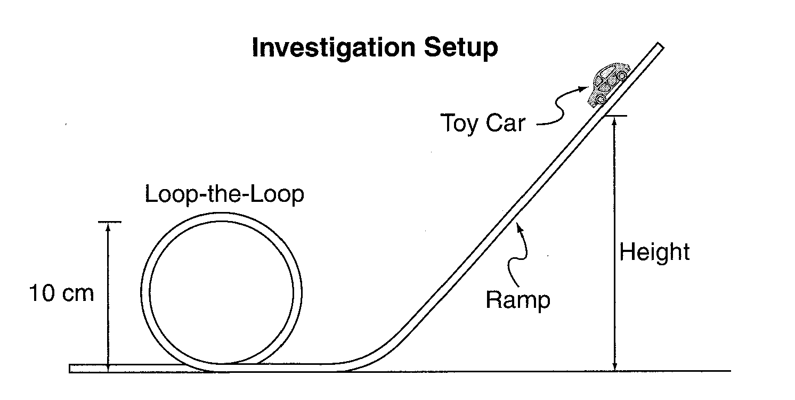

Question:
How high does a toy car need to be released for the toy car to travel completely around a loop?

Prediction:
The toy car needs to be almost 20 cm up the ramp to travel around the loop.

Materials:
ramp
toy car
meter stick to measure height in centimeters (cm)

Procedure:

- Mark the ramp at heights 5, 10, 15, 20, and 25 cm and record the heights in the data table.
- Release the toy car from each height.
- In the data table, record the car’s motion in the loop.

Loop-the-Loop
(continued)

Data:
Jane’s Loop-the-Loop Investigation

Height of toy car on ramp  (cm) | How the toy car moved in the loop
5 | Car stopped and rolled backwards when entering the loop
10 | Car got to the top of the loop then fell down
15 | Car traveled completely around the loop
20 | Car easily went around the loop
25 | Car easily went around the loop

Loop-the-Loop

1 Which variable did Jane change (manipulate)?

- A. The height the toy car starts
- B. The weight of the toy car
- C. The angle of the ramp

Item information

Correct Response: A
EALR Strand: IN Inquiry in Science
Learning Target: IN02 2.1.2 Planning and Conducting Investigations
Plan and conduct simple investigations, using appropriate tools, measures, and safety rules.
Item Characteristic: d: Given a complete description of a scientific investigation, items may ask students to identify the one variable changed (manipulated).

2 What could Jane do to give the car more energy?

- A. Release the car higher on the ramp
- B. Increase the width of the track
- C. Change the size of the loop

Item information:

Correct Response: A
EALR Strand: PR Properties of Systems
Learning Target: PR01 1.1.4 Energy Sources and Kinds
Understand that energy keeps things running; and comes in many forms.
Item Characteristic: d: Given an adequate description and/or a labeled picture/diagram of a simple physical or electrical system, items may ask students to identify or describe where an object has greater energy in a system

Loop-the-Loop

3 Instead of just releasing the toy car from a height of 10 cm, Jane pushed it.
What most likely would happen?

- A. The toy car would have too little speed to travel completely around the loop.
- B. The toy car would have enough speed to travel completely around the loop.
- C. The toy car would have too much speed to travel completely around the loop.

Item information:

Correct Response: B
EALR Strand: CH Changes in Systems
Learning Target: CH01 1.3.2 Force to Explain Motion
Investigate and recognize factors that determine the effects of a push or pull on the motion of objects.
Item Characteristic: f: Given an adequate description and/or a labeled picture/diagram of one or more objects and forces, items may ask students to identify or describe how different forces cause the same mass to move differently.

4 What heights should Jane check to find the lowest possible release height to make the car travel completely around the loop?

- A. 6-9 cm
- B. 11-14 cm
- C. 16-19 cm

Item information:

Correct Response: B
EALR Strand: IN Inquiry in Science
Learning Target: IN02 2.12 Planning and Conducting Investigations
Plan and conduct simple investigations, using appropriate tools, measures, and safety rules.
Item Characteristic: g: Given a complete description of a scientific investigation, items may ask students identify or describe how to test an investigative question.

Loop-the-Loop

5 Jane told Rick about her investigation. He went home and tried to do his own investigation.

Jane’s Loop-the-Loop Investigation Rick’s Loop-the-Loop Investigation
Height of toy car on ramp  (cm) | How the toy car moved in the loop
5 | Car stopped and rolled backwards when entering the loop
10 | Car got to the top of the loop then fell down
15 | Car traveled completely around the loop
20 | Car easily went around the loop
25 | Car easily went around the loop
Height of toy car on ramp  (cm) | How the toy car moved in the loop
5 | Car stopped and rolled backwards when entering the loop
10 | Car started up the loop but then stopped and rolled backwards
15 | Car go to the top of the loop then fell down
20 | Car traveled completely around the loop
25 | Car easily went around the loop
Rick’s results were different from Jane’s. Describe two possible explanations for the differences

Loop-the-Loop

5 (continued)

Item information:

Score points: 2
EALR Strand: IN Inquiry in Science
Learning Target: IN08 2.2.8 Evaluating Inconsistencies
Explain why similar investigations may not produce similar results.
Item Characteristic: b: Given a clear description of the investigation(s), items may ask students to identify or explain why two similar investigations produced different results.

Scoring Rubric for item number 5:

A 2-point response: The student shows the ability to explain why similar investigations may not produce similar results.

The student describes (identifies and gives details) two possible explanations for the differing results.
Examples of categories of differences:
- Different ramp or loop indicating appropriate characteristic: size, materials, length, shape, angle.
- Different car indicating appropriate characteristic: type of car, style, shape, weight, wheels, size. The student may also state that Jane’s car is faster than Rick’s.
- Different technique indicating appropriate characteristic: pushing the car, blowing on the car, measuring techniques.
Notes:
- Characteristics such as, ‘better than’ or ‘different’ must have an example of why they are ‘better than’ or how they are ‘different’.
- Student’s may use characteristics in two different categories (different ramp and different car) or may have two characteristics from one category (different ramp and different loop).

A 1-point response: The student shows some ability to explain why similar investigations may not produce similar results.

The student describes one possible explanation for the differing results
OR
The student partially describes two explanations for the differing results.

A 0-point response: The student shows little or no ability to explain why similar investigations may not produce similar results.
Loop-the-Loop

Annotated Example of a 2-point response for item number 5:

5 Jane told Rick about her investigation. He went home and tried to do his own investigation.

Jane’s Loop-the-Loop Investigation Rick’s Loop-the-Loop Investigation
Height of toy car on ramp  (cm) | How the toy car moved in the loop
5 | Car stopped and rolled backwards when entering the loop
10 | Car got to the top of the loop then fell down
15 | Car traveled completely around the loop
20 | Car easily went around the loop
25 | Car easily went around the loop
Height of toy car on ramp  (cm) | How the toy car moved in the loop
5 | Car stopped and rolled backwards when entering the loop
10 | Car started up the loop but then stopped and rolled backwards
15 | Car go to the top of the loop then fell down
20 | Car traveled completely around the loop
25 | Car easily went around the loop
Rick’s results were different from Jane’s. Describe two possible explanations for the differences

First of all, experiments usually never turn out exactly the same.
That is why scientists do their experiments many times; end up
averaging results most of the time. Rick also could have had a
heavier car, a wider or narrower ramp or a different sized loop.
Jane & Rick would have to do the experiment using the same car &
ramp to get accurate results.
Loop-the-Loop

Annotation for the sample 2-point response for item 5:

This response demonstrates the student shows the ability to explain why similar investigations may not produce similar results.

The response identifies that ”Rick also could have had a heavier car, a wider or narrower ramp or a different sized loop” which is three differences (1 point).

The response gives details of why investigations need repeating and how to insure ”accurate results” (1 point).

Note that the differences in the car or ramp given may not account for the different results. A heavier car should not affect the results; otherwise more people in a real roller coaster would affect how it travels through a loop-the-loop. However, this item is measuring an inquiry learning target not a systems understanding of the effect of weight upon falling or rolling down a ramp.
Loop-the-Loop

Annotated Example of a 1-point response for item number 5:

5 Jane told Rick about her investigation. He went home and tried to do his own investigation.

Jane’s Loop-the-Loop Investigation Rick’s Loop-the-Loop Investigation
Height of toy car on ramp  (cm) | How the toy car moved in the loop
5 | Car stopped and rolled backwards when entering the loop
10 | Car got to the top of the loop then fell down
15 | Car traveled completely around the loop
20 | Car easily went around the loop
25 | Car easily went around the loop
Height of toy car on ramp  (cm) | How the toy car moved in the loop
5 | Car stopped and rolled backwards when entering the loop
10 | Car started up the loop but then stopped and rolled backwards
15 | Car go to the top of the loop then fell down
20 | Car traveled completely around the loop
25 | Car easily went around the loop
Rick’s results were different from Jane’s. Describe two possible explanations for the differences

His was based on how high the car went and Janes was based on
how high the ramp was. My other prediction is that he might have
the car a different weight than the one Jane was using.

Annotation:

This response demonstrates the student shows some ability to explain why similar investigations may not produce similar results.

The response incorrectly describes a different purpose for Jane’s and Rick’s investigations as a possible explanation for the different results (0 point).

The response goes on to give one possible difference, ”the car a different weight” (1 point).

Loop-the-Loop

Annotated Example of a 0-point response for item number 5:

5 Jane told Rick about her investigation. He went home and tried to do his own investigation.

Jane’s Loop-the-Loop Investigation Rick’s Loop-the-Loop Investigation
Height of toy car on ramp  (cm) | How the toy car moved in the loop
5 | Car stopped and rolled backwards when entering the loop
10 | Car got to the top of the loop then fell down
15 | Car traveled completely around the loop
20 | Car easily went around the loop
25 | Car easily went around the loop
Height of toy car on ramp  (cm) | How the toy car moved in the loop
5 | Car stopped and rolled backwards when entering the loop
10 | Car started up the loop but then stopped and rolled backwards
15 | Car go to the top of the loop then fell down
20 | Car traveled completely around the loop
25 | Car easily went around the loop
Rick’s results were different from Jane’s. Describe two possible explanations for the differences

Rick’s did work it didn’t have enough power. His car just started to
roll backward and when it finally got to the top of the loop it fell
like a bag of potatoes.

Annotation:

This response demonstrates the student shows little or no ability to explain why similar investigations may not produce similar results.

The response does not describe possible explanations for the results. The response gives the results of Rick’s investigation and cannot be credited for showing understanding of this learning target (0 point).

Loop-the-Loop

6 After completing her investigation, Jane asked another question about her roller coaster model.

“How high on the ramp does a heavier toy car need to start to travel completely around the loop?”

Write a plan for an investigation that could answer Jane’s new question.

Be sure to include:
- Prediction of the investigation results
- Materials needed to do the investigation
- Procedure that includes:
- logical steps to do the investigation
- one variable kept the same (controlled)
- one variable changed (manipulated)
- any variables being measured and recorded
- how often measurements are taken and recorded

Use words, labeled pictures, and/or labeled diagrams in your response.
Question: How high on the ramp does a heavier toy car need to start to travel
completely around the loop?
Prediction:
Materials:

Loop-the-Loop

6 (continued)

You may use the space below for a labeled diagram to support your procedure.
Procedure:

Note: Students have a whole page on the actual exam

Item information:

Score points: 4
EALR Strand: IN Inquiry in Science
Learning Target: IN02 2.1.2 Planning and Conducting Investigations
Plan and conduct simple investigations, using appropriate tools, measures, and safety rules.
Item Characteristic: a: Given a complete description of a scientific investigation, items may ask students to plan a second investigation for a different question involving a minimal change in the original design.
Loop-the-Loop

Scoring Rubric for Item 6

A 4-point response: The student shows the ability to plan a scientific investigation. The student plans an investigation that earns 6-8 value points.

Prediction: 1 value point for a prediction that is related to the investigative question. The prediction must have both the variable changed (weight of toy car) and the variable measure (release height of heavier toy car).

Materials: 1 value point for listing at least a heavier toy car or materials to make the toy car heavier, a ramp, and a meter stick.

Procedure: (up to 6 value points, 1 value point per bulleted feature)
Expected attributes
- At least one variable kept the same is identified or implied such as using the same heavier car or the same ramp for each height.
- The height the toy car is released is identified or implied as the only changed variable.
- The motion of the heavier toy car is identified or implied as a measured variable.
- Measurements are recorded periodically throughout the investigation without creating artificial data. A data table can be credited to imply measurements are recorded as long as no artificial data is given.
- The steps of the investigation are logical with enough detail to repeat the procedure effectively.
Unexpected attribute that may be credited
  - Repeated trials (more one than) are planned to measure the responding variable.
Notes:
- If the student does not plan an appropriate procedure for this investigative question, she/he cannot earn any of the 6 possible value points that are awarded for procedure.
- If the procedure indicates only one measurement is taken, no points can be awarded for variables kept the same or changed because there is no chance to change or keep variable the same.

A 3-point response: The student shows some ability to plan a scientific investigation. The student plans an investigation that earns 4-5 value points.

A 2-point response: The student shows limited ability to plan a scientific investigation. The student plans an investigation that earns 3 value points.

A 1-point response: The student shows very little ability to plan a scientific investigation. The student plans an investigation that earns 1-2 value points.

A 0-point response: The student shows almost no ability to plan a scientific investigation. The student plans an investigation that earns 0 value points.
Loop-the-Loop

Scoring Rubric for Item 6 (continued)

When scoring student responses, the following table is used to keep track of the value points and convert to score points. The value point data is stored and reported along with the score points. This data directly informs instructions on released operational items.

Loop-the-Loop Item 6
Planning an Investigation
Investigation Attributes | Value Points
Prediction
Materials
Variable Kept the Same
Variable Changed
Variable Measured
Repeated Trials
Record Measurements
Logical Steps
Total  (value pt/ score pt) | /

Loop-the-Loop
Item 6
Planning an Investigation
Value Points | Score Points
6-8 | 4
4-5 | 3
3 | 2
1-2 | 1
0 | 0

Loop-the-Loop

Annotated Example of a 4-point response for item number 6:

6 After completing her investigation, Jane asked another question about her roller coaster model.

“How high on the ramp does a heavier toy car need to start to travel completely around the loop?”

Write a plan for an investigation that could answer Jane’s new question.

Be sure to include:
- Prediction of the investigation results
- Materials needed to do the investigation
- Procedure that includes:
- logical steps to do the investigation
- one variable kept the same (controlled)
- one variable changed (manipulated)
- any variables being measured and recorded
- how often measurements are taken and recorded

Use words, labeled pictures, and/or labeled diagrams in your response.
Question: How high on the ramp does a heavier toy car need to start to travel
completely around the loop?
Prediction: It needs to be at least 30 cm. high to make it around
the loop
Materials: 1) Heavier toy car
2) ramp
3) meter stick to measure the height of the ramp
4) recording materials
Loop-the-Loop

6 (continued)

You may use the space below for a labeled diagram to support your procedure.
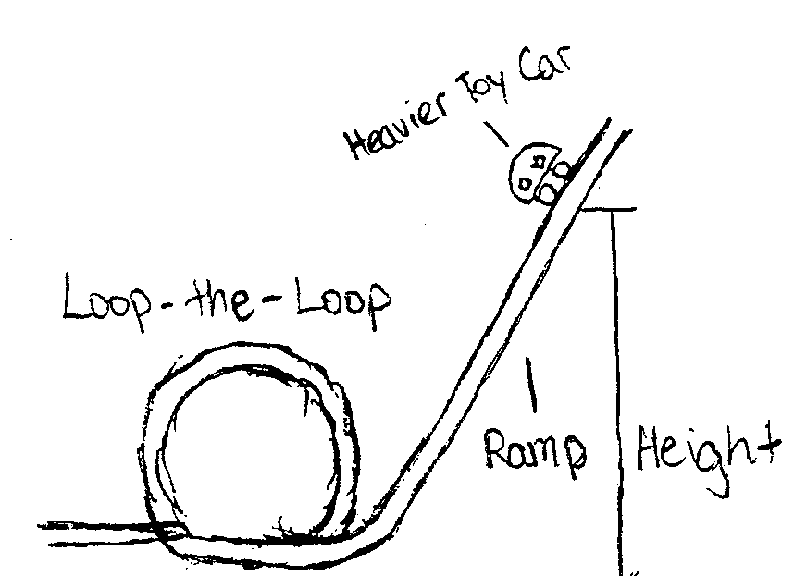
Procedure: 1) Place the car at 5 cm. high on the ramp and let it go.
2) Record how far it goes on the loop-the-loop.
3) Keep letting the car go at 5cm higher every time and keep
recording and stop when you’ve done the height of your prediction.

Annotation:

This response demonstrates that the student shows the ability to plan a scientific investigation. The response was awarded 7 value points for 4 score points.

- A prediction related the question is given, “It needs to be at least 30 cm. high” (1 point). The “It” can be assumed to mean the toy car based upon the given question.
- All the needed materials are listed (1 point).
- One variable kept the same is credited for using the same toy car for each height (1 point).
- The changed variable is implied, “at 5cm higher every time” (1 point).
- The motion of the toy car is measured, “Record how far it goes on the loop-the-loop” (1 point).
- Measurements are recorded (1 point).
- The steps of the investigation are logical with enough detail to repeat the procedure effectively (1 point).
- Repeating the trials was not indicated (no points).
Loop-the-Loop

Annotated Example of a 3-point response for item number 6:
6 After completing her investigation, Jane asked another question about her roller coaster model.

“How high on the ramp does a heavier toy car need to start to travel completely around the loop?”

Write a plan for an investigation that could answer Jane’s new question.

Be sure to include:
- Prediction of the investigation results
- Materials needed to do the investigation
- Procedure that includes:
- logical steps to do the investigation
- one variable kept the same (controlled)
- one variable changed (manipulated)
- any variables being measured and recorded
- how often measurements are taken and recorded

Use words, labeled pictures, and/or labeled diagrams in your response.
Question: How high on the ramp does a heavier toy car need to start to travel
completely around the loop?
Prediction: it could stay the same because the heaver the car the
more speed it gets.
Materials:
A heavyer toy car, ramp, ruler and a chart to write the highth
and weith of the car.

Loop-the-Loop

6 (continued)

You may use the space below for a labeled diagram to support your procedure.
Procedure: Frist I will build a ramp with a loop, then weight my car
to see how much heaver it is to the other car. Then I will test the
car by starting at 5cm to 30 cm and counting by fives. To see if
weight will change any thing.

Annotation:

This response demonstrates that the student shows some ability to plan a scientific investigation. The response was awarded 4 value points for 3 score points.

- A prediction related the question is given, “It could stay the same” (1 point).
- All the needed materials are listed (1 point).
- One variable kept the same is credited for using the same toy car for each height (1 point).
- The changed variable is implied, “starting at 5cm to 30cm and counting by fives” (1 point).
- The motion of the toy car is not measured (0 points).
- Measurements are not recorded (0 points).
- The steps of the investigation are not logical. The statement “to see if weight will change anything” is too vague to repeat the investigation (0 points).
- Repeating the trials was not indicated (no points).

Loop-the-Loop

Annotated Example a 2-point response for item number 6:

6 After completing her investigation, Jane asked another question about her roller coaster model.

“How high on the ramp does a heavier toy car nee to start to travel completely around the loop?”

Write a plan for an investigation that could answer Jane’s new question.

Be sure to include:
- Prediction of the investigation results
- Materials needed to do the investigation
- Procedure that includes:
- logical steps to do the investigation
- one variable kept the same (controlled)
- one variable changed (manipulated)
- any variables being measured and recorded
- how often measurements are taken and recorded

Use words, labeled pictures, and/or labeled diagrams in your response.
Question: How high on the ramp does a heavier toy car need to start to travel
completely around the loop?
Prediction: I think the ramp needs to be more wider and stronger
to hold it.
Materials: Your going to need a ramp with a loop, a measuring stick,
a car and a pencil and paper to record
Loop-the-Loop

6 (continued)

You may use the space below for a labeled diagram to support your procedure.
Procedure: Once you get the materials setup the ramp so it looks like
this. Then take the measuring stick and measure it so there’s 5,
10, 15, 20, 25 somewhere on it. After that test it and record it.

Annotation:

This response demonstrates that the student shows limited ability to plan a scientific investigation. The response was awarded 3 value points for 2 score points.

- The prediction does not answer the investigative (0 point).
- A heavier car is missing from the materials (0 point).
- One variable kept the same is credited for using the same ramp for each height (1 point).
- The changed variable can be credited for measuring “5, 10, 15, 20, 25 somewhere on it” because the “it” can be taken to mean the ramp (1 point).
- The motion of the toy car is not measured (0 point).
- Something is recorded (1 point).
- The steps of the investigation are not logical. (0 point).
- Repeating the trials was not indicated (no point).
Loop-the-Loop

Annotated Example of a 1-point response for item number 6:

6 After completing her investigation, Jane asked another question about her roller coaster model.

“How high on the ramp does a heavier toy car need to start to travel completely around the loop?”

Write a plan for an investigation that could answer Jane’s new question.

Be sure to include:
- Prediction of the investigation results
- Materials needed to do the investigation
- Procedure that includes:
- logical steps to do the investigation
- one variable kept the same (controlled)
- one variable changed (manipulated)
- any variables being measured and recorded
- how often measurements are taken and recorded

Use words, labeled pictures, and/or labeled diagrams in your response.
Question: How high on the ramp does a heavier toy car need to start to travel
completely around the loop?
Prediction: I believe It needs 27cm to make it go around
Materials: Ramp, heavy toy car, and meter stick

Loop-the-Loop

6 (continued)

You may use the space below for a labeled diagram to support your procedure.
Procedure:
The procedure this time is to build the ramp, place the car at the
end and before you let the car go measure it.

Annotation:

This response demonstrates that the student shows very little ability to plan a scientific investigation. The response was awarded 2 value points for 1 score points.

- A prediction related the question is given, “It needs 27 cm to make it go around” (1 point).
- All the needed materials are listed (1 point).
This procedure indicates only one measurement is taken, no points can be awarded for controlled or manipulated variables because there is no chance to change or keep constant any variable.
- One variable kept the same and one changed variable (0 point).
- The motion of the toy car is not necessarily measured. The statement “measure it” is too vague to credit (0 point).
- Measurements are not recorded (0 point).
- The steps of the investigation are too vague to repeat and, therefore, are not logical (0 point).
- Repeating the trials was not indicated (no point).
Loop-the-Loop

Annotated Example of a 0-point response for item number 6:

6 After completing her investigation, Jane asked another question about her roller coaster model.

“How high on the ramp does a heavier toy car need to start to travel completely around the loop?”

Write a plan for an investigation that could answer Jane’s new question.

Be sure to include:
- Prediction of the investigation results
- Materials needed to do the investigation
- Procedure that includes:
- logical steps to do the investigation
- one variable kept the same (controlled)
- one variable changed (manipulated)
- any variables being measured and recorded
- how often measurements are taken and recorded

Use words, labeled pictures, and/or labeled diagrams in your response.
Question: How high on the ramp does a heavier toy car need to start to travel
completely around the loop?
Prediction: use a different toy car
Materials: ramp, toy car, and a meterstick

Loop-the-Loop

6 (continued)

You may use the space below for a labeled diagram to support your procedure.
Procedure: If Jane uses a different toy car and a higher ramp she
will find out the answer to her question

Annotation:

This response demonstrates that the student shows little or no ability to plan a scientific investigation. The response was awarded 0 value points for 0 score points.

- The statement “use a different toy car” is not a prediction (0 points).
- The list of materials is a copy of the scenario and cannot be credited (0 points).

The statement given as a procedure cannot be credited for any of the procedure value points.

Magnetic Force Stand Alone Item

7 Look at the figures below.
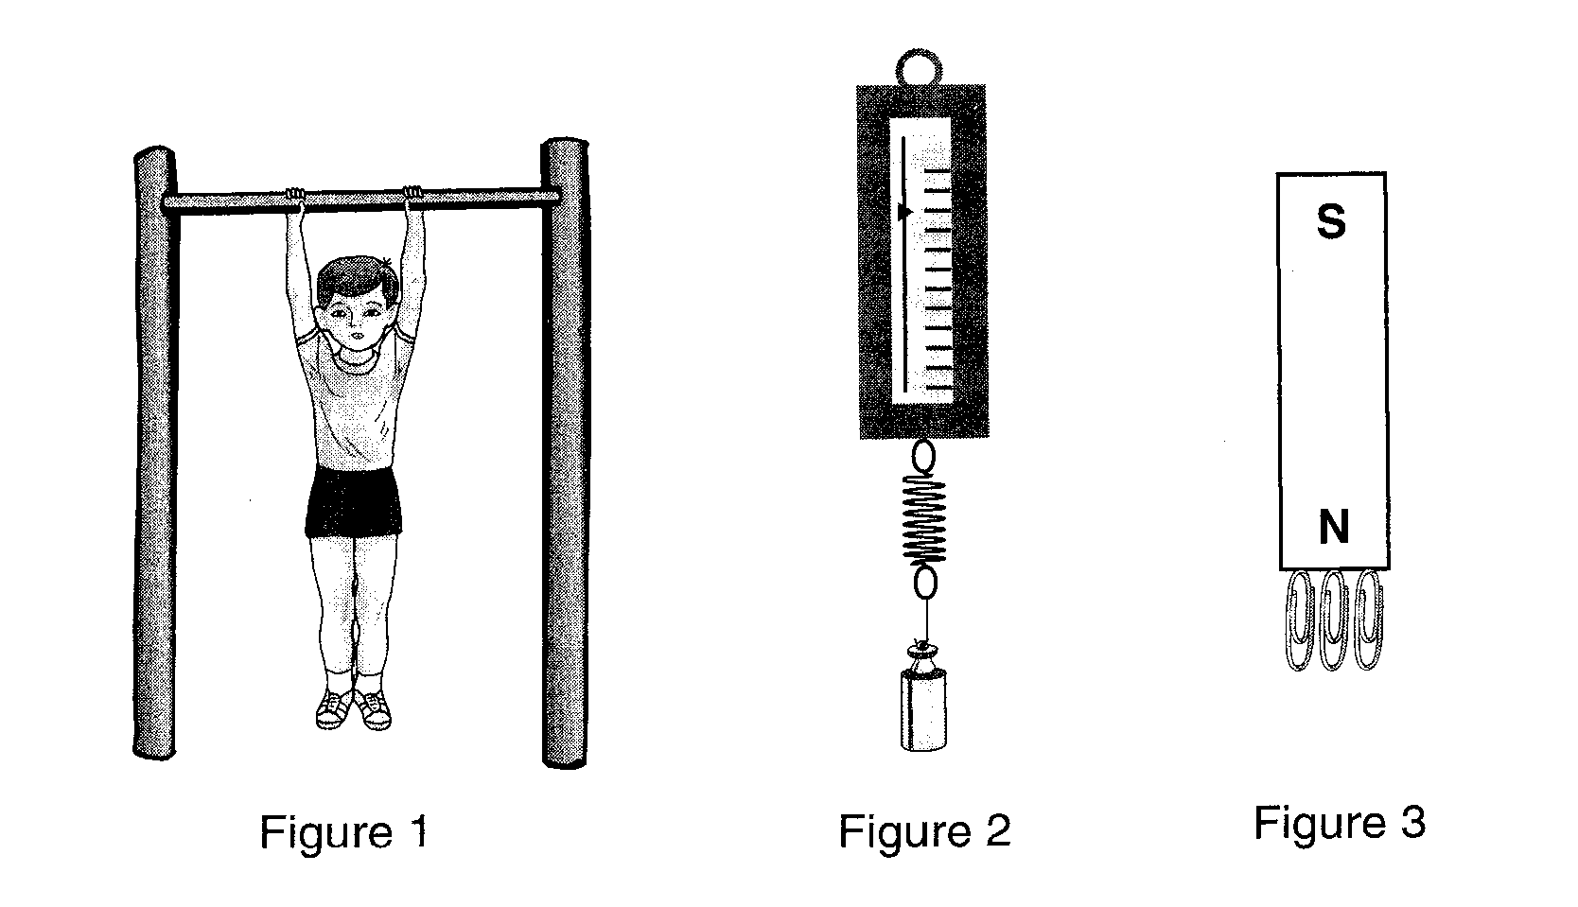

Which figure best demonstrates a magnetic force?

- A. Figure 1
- B. Figure 2
- C. Figure 3

Item information

Correct Response: C
EALR Strand: CH Changes in Systems
Learning Target: CH01 1.3.1 Nature of Forces
Describe forces in terms of strength and direction.
Item Characteristic: c: Given an adequate description and/or a labeled picture/diagram of one or more objects and forces acting, items may ask students to identify the force that is acting on the object(s) (e.g. magnetic, electrical, gravitational).

Lightning and Thunder Stand Alone Item

8 At camp, Raj sees a lightning storm. He sees the lightning before he hears the thunder. What does this show?

- A. Light moves faster than sound
- B. Light moves slower than sound
- C. Light and sound move at the same speed

Item information

Correct Response: A
EALR Strand: PR Properties of Systems
Learning Target: PR01 1.1.3 Wave Behavior
Describe experiences with sound, for example vibrations, echoes, and pitch. Describe experiences with light in terms of bouncing off, passing through, and changes in path and direction.
Item Characteristic: c: Given an adequate description and/or a labeled picture/diagram of an appropriate system, items may ask students to identify or describe the relative speed of sound versus light.

Gaining Energy Stand Alone Item

9 Which object below is gaining energy?

- A. A rubber band that is being stretched
- B. A battery in a flashlight that is on
- C. A candle that is burning

Item information

Correct Response: A
EALR Strand: ST Structure of Systems
Learning Target: ST01 1.2.2 Energy Transfers and Transformation
Know that energy can be transferred from one object to another and can be transformed from one type to another.
Item Characteristic: b: Given an adequate description and/or a labeled picture/diagram of an appropriate system, items may ask students to identify or describe the energy before and after a change has occurred (i.e. the energy of motion of a hands clapping changing into sound energy).

Pencil System Stand Alone Item

10 A system is anything with interconnected parts, such as the pencil in the picture in the box below.

  - Label four parts that make up the pencil system pictured in the box below.

  - Describe what would happen if one part of the pencil system were missing and explain why this would happen.

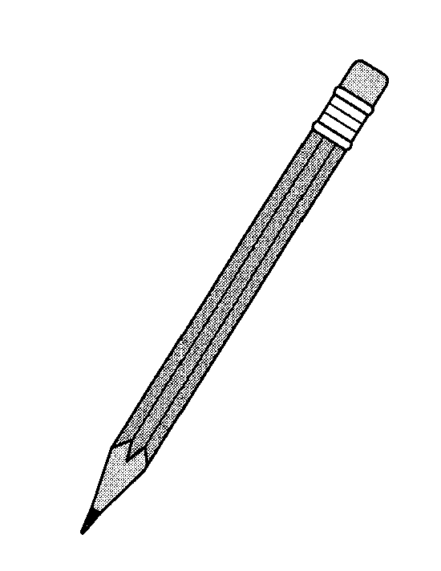

Pencil System Stand Alone Item

10 (continued)

Item information

Score Points: 2
EALR Strand: ST Structure of Systems
Learning Target: ST01 1.2.1 Structure of Physical Systems
Identify the parts of a physical system, how the parts go together, and how they depend on each other in systems other than those described in other ST learning targets.
Item Characteristics: Given an adequate description and/or a labeled picture/diagram of an appropriate system, items may ask students to:
b: Identify or describe how the parts of the system go together.
e: Identify or describe what would happen if one part of the system was missing or broken.

Pencil System Stand Alone Item

10 (continued)

Scoring Rubric for item number 10:

A 2-point response: The student shows the ability to identify the parts of a physical system, how the parts go together, and how they depend on each other.

The student clearly labels four of the following parts of the pencil:
- eraser or an appropriate name like rubber
- lead/graphite or an appropriate name like tip
- wood/plastic or an appropriate name like stick or part you hold on to
- band that holds eraser or an appropriate name like metal thing
- paint/coating
- glue is acceptable if accompanied by an explanation

AND
The student chooses one part and gives a clear and accurate explanation of what would happen if the part were missing.

Example:
Four parts of the system are the eraser, the lead, the wood, and the metal band. If the eraser is missing, the writer cannot erase the writing.

Notes:
- Student may label the 4 parts of the pencil in the diagram provided without writing in the space provided for the point awarded to clearly naming the four parts of the pencil
- The wooden shaft can be referred to the base, handle, body, or wood. However, top or bottom does not suffice to identify the tip or eraser.

A 1-point response: The student shows some ability to identify the parts of a physical system, how the parts go together, and how they depend on each other.

The student clearly labels four parts of the pencil.
OR
The student chooses one part and gives a clear and accurate explanation of what would happen if the part were missing.

A 0-point response: The student shows little or no ability to identify the parts of a physical system, how the parts go together, and how they depend on each other.
Pencil System

Annotated Example of a 2-point response for item number 10:

10 A system is anything with interconnected parts, such as the pencil in the picture in the box below.

  - Label four parts that make up the pencil system pictured in the box below.

  - Describe what would happen if one part of the pencil system were missing and explain why this would happen.

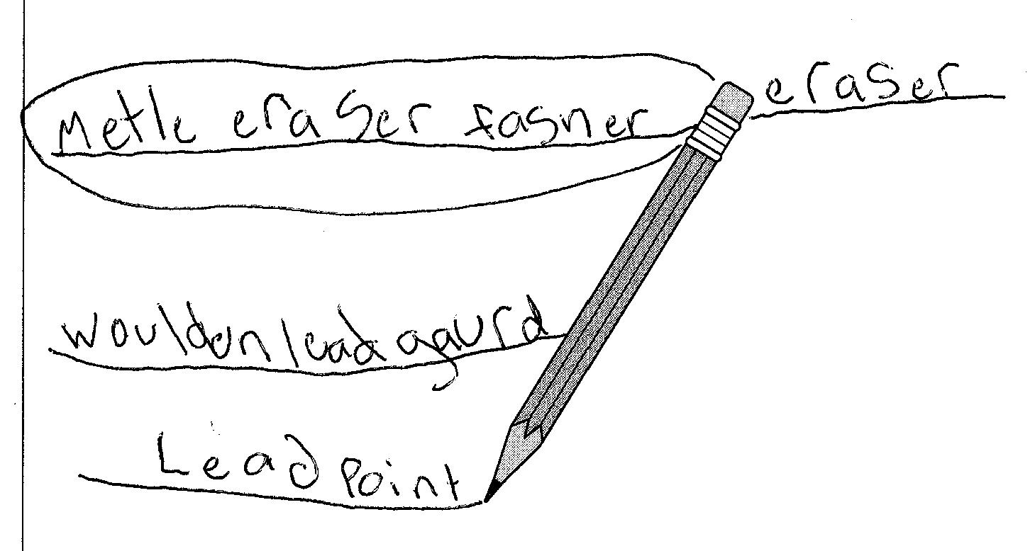
If the pencil did not have the mettle eraser fastener the eraser
would fall of.

Annotation:

This response demonstrates the student shows the ability to identify the parts of a physical system, how the parts go together, and how they depend on each other.

The response labels the four parts of the pencil systems (1 point). Notice that the creative spelling and labels like “woulden lead guard” are acceptable.

The response describes what would happen if the “mettle eraser fastener” were missing (1 point).
Pencil System

Annotated Example of a 1-point response for item number 10:

10 A system is anything with interconnected parts, such as the pencil in the picture in the box below.

  - Label four parts that make up the pencil system pictured in the box below.

  - Describe what would happen if one part of the pencil system were missing and explain why this would happen.

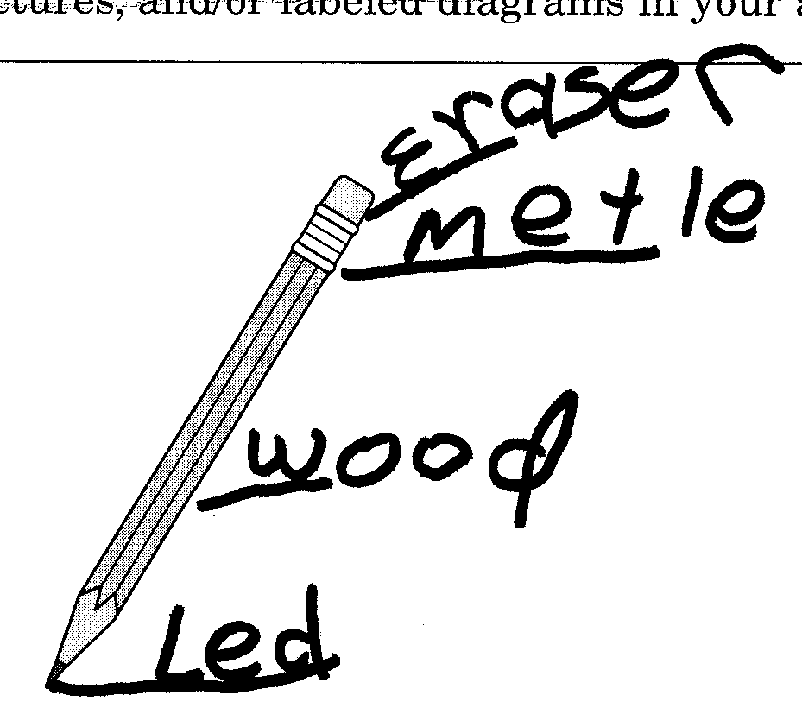
The ereser
The meldle to hold the eraser on. The wood. The led

Annotation:

This response demonstrates the student shows some ability to identify the parts of a physical system, how the parts go together, and how they depend on each other.

The response labels four parts of the pencil system (1 point).

The response lists the four parts but does not attempt to describe what would happen if one part were missing (0 point).
Pencil System

Annotated Example of a 0-point response for item number 10:

10 A system is anything with interconnected parts, such as the pencil in the picture in the box below.

  - Label four parts that make up the pencil system pictured in the box below.

  - Describe what would happen if one part of the pencil system were missing and explain why this would happen.

If some of the pencil system were gone it would not work

Annotation:

This response demonstrates the student shows little or no ability to identify the parts of a physical system, how the parts go together, and how they depend on each other.

The response does not label the four parts of the pencil system (0 point).

The response description ”If some of the pencil system were gone it would not work” is too vague to credit (0 point).

